Department of Information Technology
Alumni Testimonials

- Name: Shifa Rifat
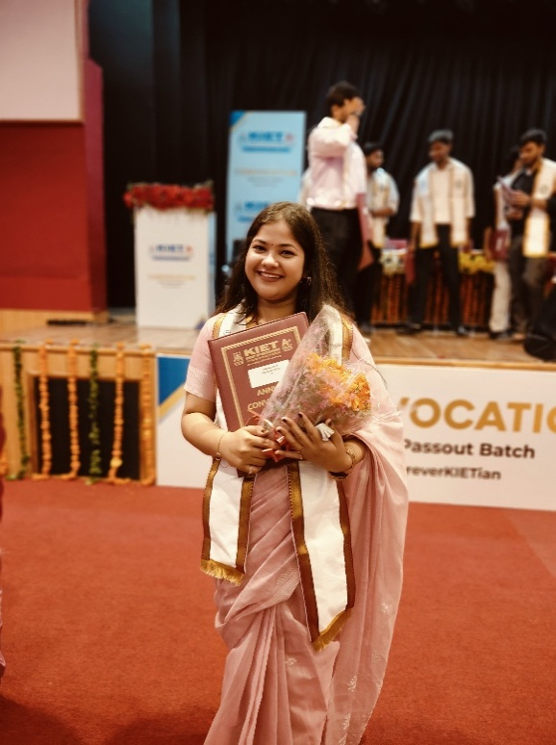

"From the quiet focus of lab benches to the energy of late-night project sprints, every experience at KIET has shaped not just my career—but my character. I am sincerely grateful to the Information Technology department—our HODs, faculty, and every mentor—whose unwavering support, insight, and belief in me made this journey possible. Beyond technical skills, I leave with a sense of purpose, resilience, and memories that will echo far beyond these walls."
Associate Software Engineer at ServiceNow
Information Technology
Batch 2024

- Name: Unnati Bhardwaj

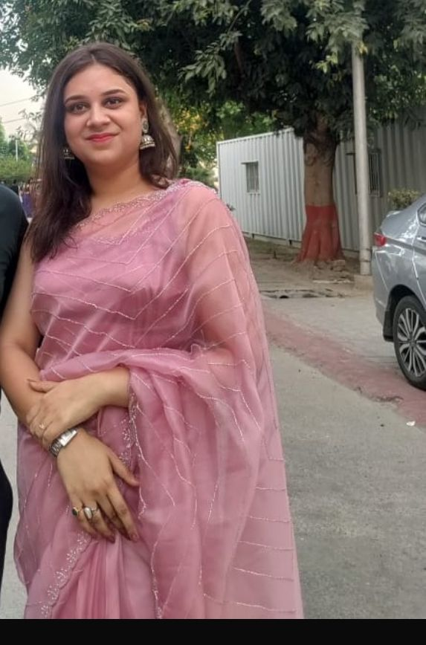
"Supportive mentors and a culture of innovation in the IT Department gave me the space to experiment, build, and grow. Some of those experiments turned into proud moments on national and global platforms. KIET enriched my journey with experiences that reached far beyond the classroom."
Company - Smarter.Codes
Designation - Product Consultant
Department + Batch - Information Technology (IT - 2024)

3. Name: Isha Rastogi
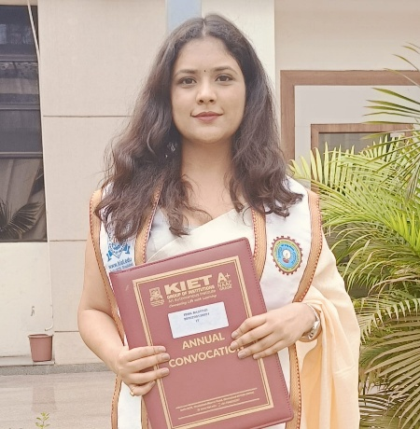
"I feel proud and grateful for the journey at KIET that shaped my professional foundation. The academic environment, dedicated faculty, and constant support from the Information Technology department played a vital role in preparing me for the industry. Now, working at Microsoft, I carry with me not just technical skills but also the confidence, discipline, and values instilled during my time at KIET. I am thankful for all the opportunities and encouragement that helped turn my aspirations into reality."
Designation - Software Engineer (Microsoft)
Department / Batch - IT 2024

4. Name: Chinmoy Chakraborty
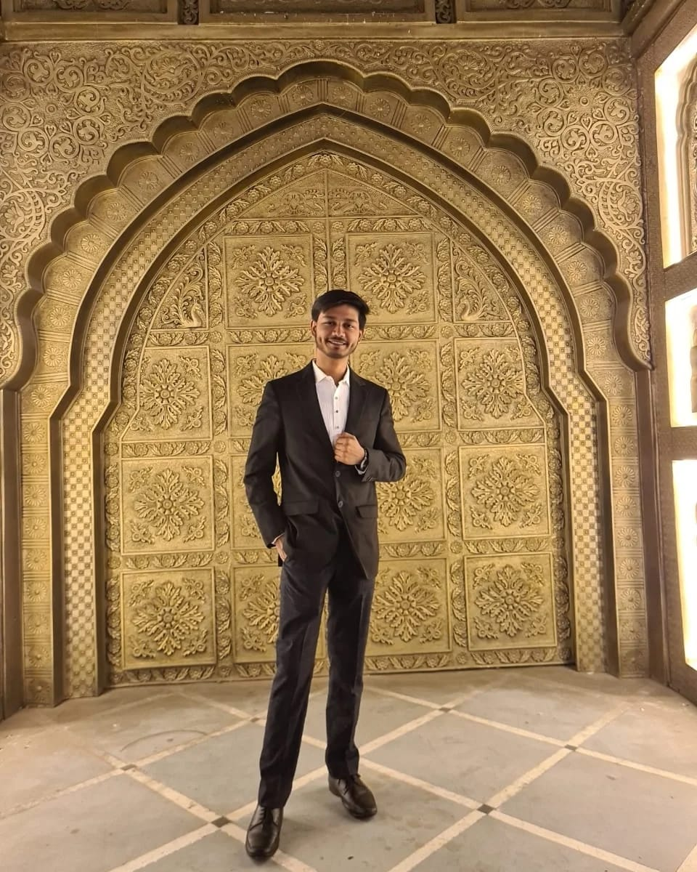

"I've been fortunate to be a part of the IT department at KIET Group of Institutions. The department has helped me establish a strong academic foundation, as well as foster personal growth. The faculty has always been supportive and has guided us towards excellence.
The Department of IT has also provided students with a rich environment to explore industry technology through various student clubs. Above all, the department has ensured an all-round holistic development of students, and I am grateful to be a part of such a vibrant ecosystem."
SDE @Zomato
Department: IT Batch: 2023

